# React -Lifting state up Number2TextConverter

Create react Number2TextConverter parent component that contains two child components Numbers2Text, Text2Number , this components enables converting from text to number and from number to text.

1. Number2TextConverter - handles onNumberChange, onTextChange ,convert the values, and reassigns the text , number in the component state
2. Numbers2Text – allows to display and change a number between 0 – 9 , handles onChange event .
3. Text2Number – allows to display and change a text between zero – nine , handles onChange event.

*GUI example:

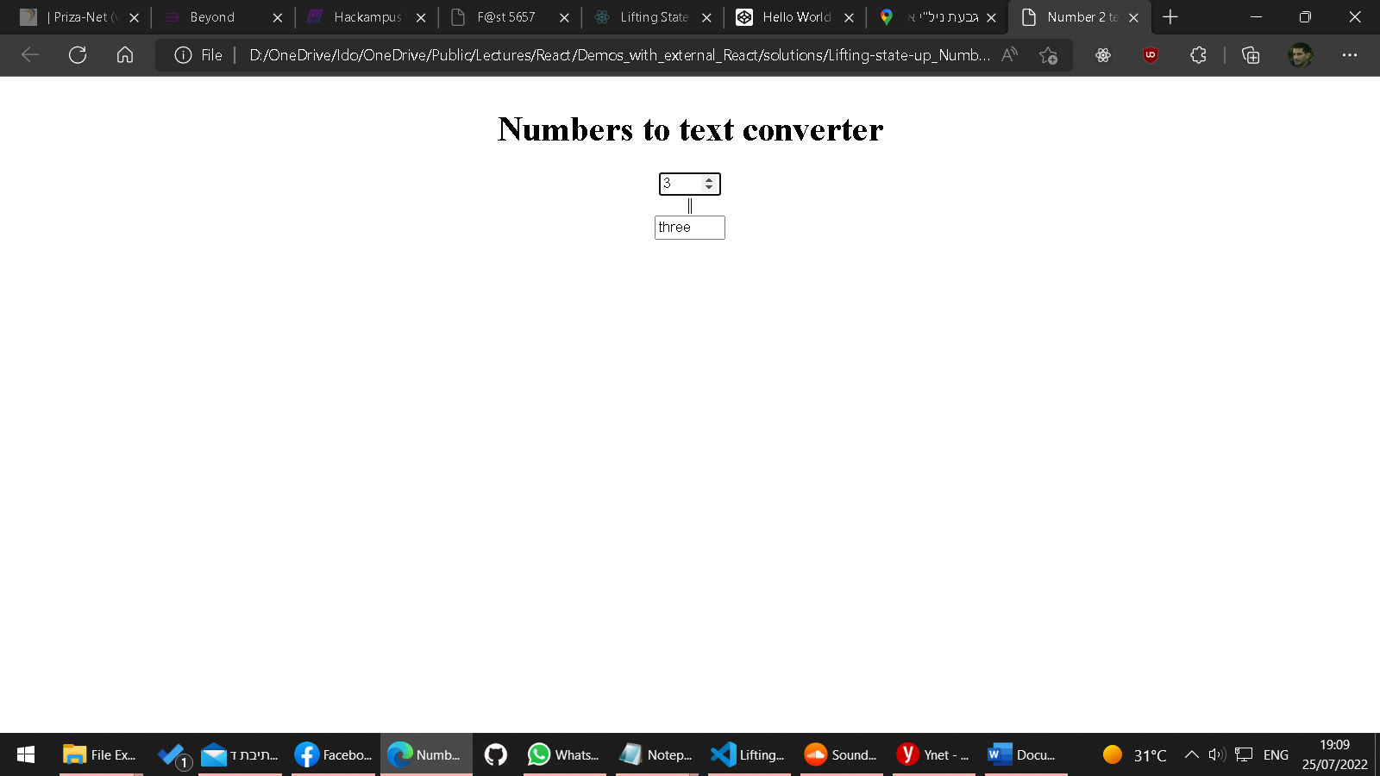

*[Lifting State Up – React (reactjs.org)](https://reactjs.org/docs/lifting-state-up.html)